Z Chiropractic & Decompression
Confidential Patient Case History

Name_____________________________________________________ Date______________
Address__________________________________City___________State_____Zip_________
Home Phone__________________________ Cell Phone_______________________
Occupation_______________________ Email___________________________________
Birth Date ____/____/____ Age_____ Spouse’s Name_____________# of Children______
Who can we thank for your referral? ______________________________________________
Emergency Contact: Name/Relationship__________________________ Phone____________________

1. Please describe what brought you in today:
____________________________________________________________________________________________
____________________________________________________________________________________________
____________________________________________________________________________________________
____________________________________________________________________________________________
____________________________________________________________________________________________
____________________________________________________________________________________________ ____________________________________________________________________________________________

2. Indicate on the drawings below where you have pain/symptoms
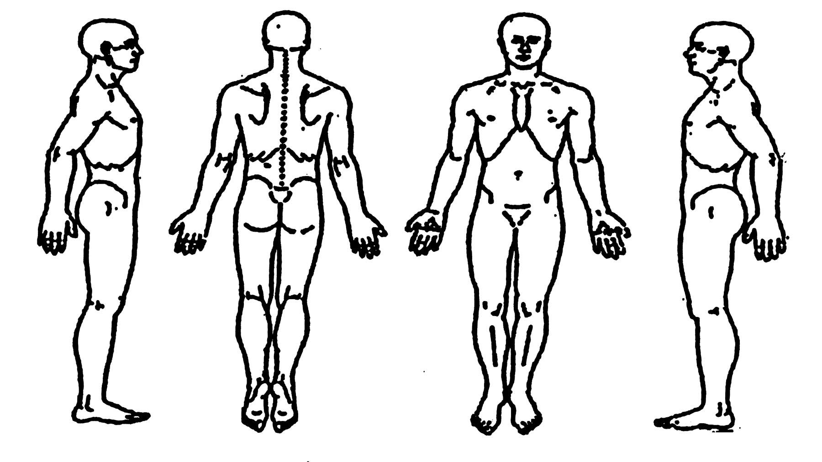
3. How often do you experience your symptoms?
□ Constantly (76-100% of the time) □ Occasionally (26-50% of the time)
□ Frequently (51-75% of the time) □ Intermittently (1-25% of the time)

4. How would you describe the type of pain?
□ Sharp □ Numb
□ Dull □ Tingly
□ Intense □ Sharp with motion
□ Achy □ Shooting with motion
□ Burning □ Stabbing with motion
□ Shooting □ Radiates/Travels:_______________________________________________
□ Stiff □ Other:__________________________________________________

5. How are your symptoms changing with time?
□ Getting Worse □ Staying the Same □ Getting Better

6. Using a scale from 0-10 (10 being the worst), how would you rate your problem?
0 1 2 3 4 5 6 7 8 9 10 (Please circle)

7. How much has the problem interfered with your work?
□ Not at all □ A little bit □ Moderately □ Quite a bit □ Extremely

8. How much has the problem interfered with your social activities?
□ Not at all □ A little bit □ Moderately Quite a bit □ Extremely

9. Who else have you seen for your problem?
□ Chiropractor □ Neurologist □ Primary Care Physician
□ ER physician □ Orthopedist □ Other:_____________
□ Massage Therapist □ Physical Therapist □ No one
Name of physician ________________________ City __________________ Phone ________________

10. How long have you had this problem? _______________________________________________

11. How do you think your problem began?
___________________________________________________________________________________

12. Do you consider this problem to be severe?
□ Yes □ Yes, at times □ No

13. What makes your problem worse?
____________________________________________________________________________________

14. What makes your problem better?
____________________________________________________________________________________

15. What concerns you the most about your problem; what does it prevent you from doing?
____________________________________________________________________________________
____________________________________________________________________________________
16. How long has it been since you really felt good? ______________________________________________________________________________________
17. List previous diagnoses and treatment you have received for present condition______________________________________________________________________________

18. What is your: Height___________ Weight _____________

19. What type of exercise do you do?
□ Strenuous □ Moderate □ Light □ None

20. For each of the conditions listed below, place a check in the "past" column if you have had the condition in the past. If you presently have a condition listed below, place a check in the "present" column.

Past Present Past Present Past Present
□ □ Headaches □ □ High Blood Pressure □ □ Diabetes
□ □ Neck Pain □ □ Heart Attack □ □ Excessive Thirst
□ □ Upper Back Pain □ □ Chest Pains □ □ Frequent Urination
□ □ mid Back Pain □ □ Stroke □ □ Smoking/Tobacco Use
□ □ Low Back Pain □ □ Angina □ □ Drug/Alcohol Dependence
□ □ Shoulder Pain □ □ Kidney Stones □ □ Allergies
□ □ Elbow/Upper Arm Pain □ □ Kidney Disorders □ □ Depression
□ □ Wrist Pain □ □ Bladder Infection □ □ Systemic Lupus
□ □ Hand Pain □ □ Painful Urination □ □ Epilepsy
□ □ Hip Pain □ □ Loss of Bladder Control □ □ Dermatitis/Eczema/Rash
□ □ Upper Leg Pain □ □ Prostate Problems □ □ HIV/AIDS
□ □ Knee Pain □ □ Abnormal Weight Gain/Loss
□ □ Ankle/Foot Pain □ □ Loss of Appetite For Females Only
□ □ Jaw Pain □ □ Abdominal Pain □ □ Birth Control Pills
□ □ Joint Pain/Stiffness □ □ Ulcer □ □ Hormonal Replacement
□ □ Arthritis □ □ Hepatitis Currently Pregnant?__________
□ □ Rheumatoid Arthritis □ □ Liver/Gall Bladder Disorder
□ □ Cancer □ □ General Fatigue
□ □ Tumor □ □ Muscular coordination
□ □ Asthma □ □ Visual Disturbances
□ □ Chronic Sinusitis □ □ Dizziness
□ □ Other:____________________________

21. List all prescription medications you are currently taking:
______________________________________________________________________________________
______________________________________________________________________________________

22. List all of the over-the-counter medications/ supplements you are currently taking:
______________________________________________________________________________________
______________________________________________________________________________________

23. List all surgical procedures you have had:
______________________________________________________________________________________
______________________________________________________________________________________
24. Have you ever been hospitalized? □ No □ Yes
if yes, why _____________________________________________________________________________

25. Please list any significant past trauma, slips, falls, broken bones, and/or accidents you’ve had from childhood to present: Date:
______________________________________________________________________________________
______________________________________________________________________________________
26. What activities do you do at work?
□ Sit: □ Most of the day □ Half the day □ A little of the day
□ Stand: □ Most of the day □ Half the day □ A little of the day
□ Computer work: □ Most of the day □ Half the day □ A little of the day
□ On the phone: □ Most of the day □ Half of the day □ A little of the day

27. What activities do you do outside of work?
______________________________________________________________________________________

28. Please list main goals of treatment:
______________________________________________________________________________________
______________________________________________________________________________________
29.Please select services that you are interested in:
□ Acupuncture □ Chiropractic Adjustments □ Decompression □ Problem Focused Rehab

30. Anything else pertinent to your visit today? ______________________________________________
______________________________________________________________________________________

Patient Informed Consent

I, ___________________________________________, the undersigned, consent to care at this clinic. I understand that I have the opportunity to discuss with the doctor and/or with other office personnel, the nature and purpose of chiropractic adjustments, massage, decompression, and wellness related care. I hereby request and consent to the performance of chiropractic procedures, including various modes of physiotherapy, diagnostic x-rays, and any supportive therapies on me (or on the patient above, for whom I am legally responsible) by Jeffrey Zwierstra, D.C. and support team at Z Chiropractic & Decompression.

I also understand that as is with all healthcare treatments, results are not guaranteed, there is no promise to cure and that there are some risks. Risks include, but are not limited to; aggravating and/or temporary increase in symptoms, muscle spasms, fractures, disc injuries, strokes, dislocations and sprains. I do not expect the doctor to be able to anticipate and explain all risks and complications, and I wish to rely on the doctor’s judgment, based upon the facts then known, is in my best interests. I further understand that chiropractic adjustments and supportive treatment is designed to reduce and/or correct subluxations allowing the body to return to improved health. It can also alleviate certain symptoms through a conservative approach with hopes to avoid more invasive procedures.

I have read, or have had read to me, the above consent. I have also had an opportunity to ask questions about its content, and by signing below I agree to the above-named procedures.

Patient/Guardian Signature ____________________________________ Date _____________

Z Chiropractic & Decompression

Financial Agreement
Please remember that insurance is considered a method of reimbursing the patient for fees put to
the doctor and is not a substitute for payment. Some companies pay fixed allowances
for certain procedures, and others pay a percentage of the charge. It is your responsibility to pay
any deductible amount, co-insurance, or any other balance not paid by your insurance.

IN ORDER TO CONTROL YOUR OUTSTANDING BALANCE, IT IS OUR POLICY TO COLLECT
CO-PAYS, CO-INSURANCE AND DEDUCTIBLE AT TIME OF SERVICE.

I authorize the release of any information necessary to determine liability for payment and to
obtain reimbursement on any claim.

Patient/Guardian Signature ____________________________________ Date _____________

LEGAL ASSIGNMENT OF BENEFITS AND RELEASE OF MEDICAL DOCUMENTS
In considering the amount of medical expenses to be incurred, I, the undersigned, have insurance
and/or employee health care benefits coverage with the above captioned, and hereby assign and convey
directly to Z Chiropractic & Decompression all medical benefits and/or insurance reimbursement, if any, otherwise payable tome for services rendered from such doctor and clinic. I understand that I am financially responsible for all charges regardless of any applicable insurance or benefit payments. I hereby authorize the doctor to release all medical information necessary to process this claim. I hereby authorize any plan administrator or fiduciary, insurer and my attorney to release to such doctor and clinic any and all plan documents, insurance policy and/or settlement information upon written request from such doctor and clinic in order to claim such medical benefits, reimbursement or any applicable remedies. I authorize the use of this signature on all my insurance and/or employee health benefits claim submissions.
I hereby convey to the above named doctor and clinic to the full extent permissible under the law
and under the any applicable insurance policies and/or employee health care plan any claim, chose in
action, or other right I may have to such insurance and/or employee health care benefits coverage under
any applicable insurance policies and/or employee health care plan with respect to medical expenses
incurred as a result of the medical services I received from the above named doctor and clinic and to the
extent permissible under the law to claim such medical benefits, insurance reimbursement and any
applicable remedies. Further, in response to any reasonable request for cooperation, I agree to cooperate
with such doctor and clinic in any attempts by such doctor and clinic to pursue such claim, chose in action outright against my insurers and/or employee health care plan.
This assignment will remain in effect until revoked by me in writing. A photocopy of this assignment
is to be considered as valid as the original. I have read and fully understand this agreement.

Patient/Guardian Signature ____________________________________ Date _____________

HIPPA Privacy Notice
The patient understands and agrees to allow this chiropractic office to use their Patient Health Information for the purpose of treatment, payment, healthcare operations, and coordination of care. We want you to know how your Patient Health Information is going to be used in this office and your rights concerning those records. If you would like to have a more detailed account of our policies and procedures concerning the privacy of your Patient Health Information we encourage you to read the HIPAA NOTICE that is available to you at the front desk before signing this consent. If there is anyone you do not want to receive your medical records, please inform our office.

Patient/Guardian Signature ____________________________________ Date _____________

